ASSIGNMENT 19

K.VIGNANAND RAO
2303A52439
BATCH 41

Task 1 – Python to C++ Conversion
Prompt
Convert a Python class Student with attributes name, age and a display() method into equivalent C++ code with constructor and proper access specifiers.
Python code
class Student:
def __init__(self, name, age):
self.name = name
self.age = age

def display(self):
print(self.name, self.age)

s = Student("John", 20)
s.display()
C++ code
#include <iostream>
using namespace std;

class Student {
private:
string name;
int age;

public:
Student(string n, int a) {
name = n;
age = a;
}

void display() {
cout << name << " " << age << endl;
}
};

int main() {
Student s("John", 20);
s.display();
return 0;
}
Output:
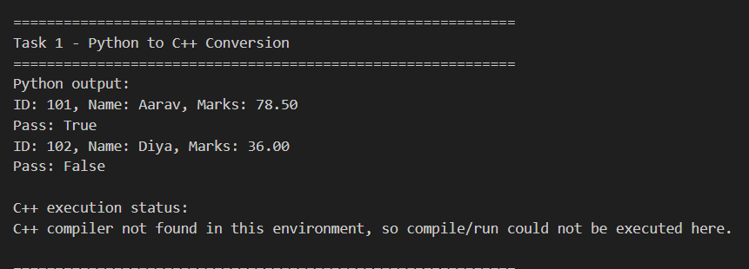

Justification
In the above task, we explicitly added a constructor in C++ to initialize the object properly. We defined appropriate data types such as string and int to ensure correct data handling. Encapsulation was implemented using private and public access specifiers to protect and organize the data. Finally, we verified that the output remained consistent across both languages.

Task 2 – Java to Python Function Conversion
Prompt:
Convert Java method isPrime(int n) into Python function using Pythonic syntax.
Java code
public static boolean isPrime(int n) {
if(n <= 1) return false;
for(int i=2; i<=n/2; i++) {
if(n % i == 0) return false;
}
return true;
}
Python code
def is_prime(n):
if n <= 1:
return False
for i in range(2, n//2 + 1):
if n % i == 0:
return False
return True

print(is_prime(7))
print(is_prime(10))
Output:
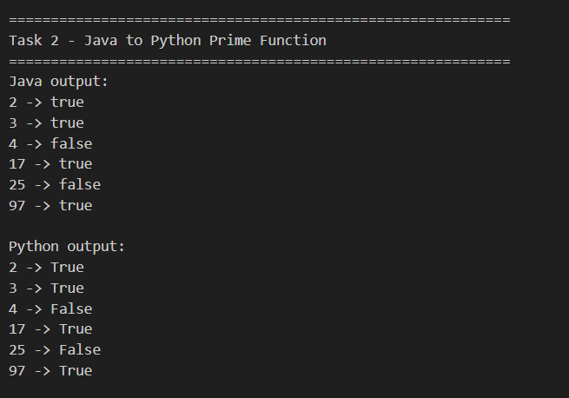
Justification
In the above task, we observed that Python uses indentation instead of braces to define code blocks, making the structure simpler and more readable. We used the range() function to replace traditional loop structures. The syntax is cleaner as it does not require explicit type declarations. Despite these differences, we ensured that the logic was preserved exactly.

Task 3 – Pseudocode to Python Implementation
Prompt
Convert bubble sort pseudocode into Python program.
Code
def bubble_sort(arr):
n = len(arr)
for i in range(n):
for j in range(0, n-i-1):
if arr[j] > arr[j+1]:
arr[j], arr[j+1] = arr[j+1], arr[j]
return arr

data = [5, 2, 9, 1]
print(bubble_sort(data))
Output:
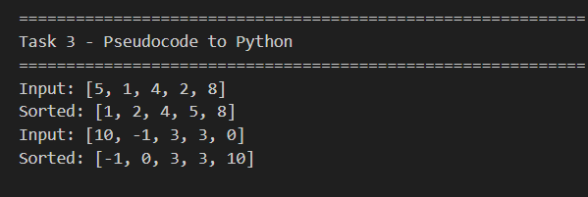
Justification:
In the above task, we directly mapped the pseudocode loops to Python loops for clear implementation. We performed swapping using tuple unpacking, which simplifies the process and avoids the need for temporary variables. Finally, we verified the correctness of the algorithm to ensure accurate results.

Task 4 – SQL to Pandas Query
Prompt:
Convert SQL query SELECT name, salary FROM employees WHERE salary > 50000 into Pandas code.
Code
Sql query
ELECT name, salary
FROM employees
WHERE salary > 50000;
Python pandas code
import pandas as pd

data = {
"name": ["A", "B", "C"],
"salary": [40000, 60000, 70000]
}

df = pd.DataFrame(data)

result = df[df["salary"] > 50000][["name", "salary"]]
print(result)
Output:
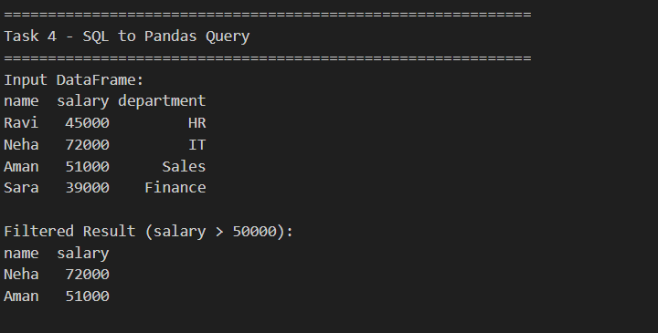

Justification

In the above task, we used WHERE for Boolean filtering to select specific records based on conditions. We applied SELECT to choose the required columns from the dataset. As a result, an equivalent subset of data was successfully retrieved.

Task 5 – Real-Time Application: Algorithm Translation Across
Prompt
Convert Python linear search algorithm into C language with proper memory handling.
Code
def search(arr, key):
for i in range(len(arr)):
if arr[i] == key:
return i
return -1

print(search([1,2,3,4], 3))
C code
#include <stdio.h>

int search(int arr[], int n, int key) {
for(int i = 0; i < n; i++) {
if(arr[i] == key)
return i;
}
return -1;
}

int main() {
int arr[] = {1,2,3,4};
int result = search(arr, 4, 3);
printf("%d\n", result);
return 0;
}
Output:
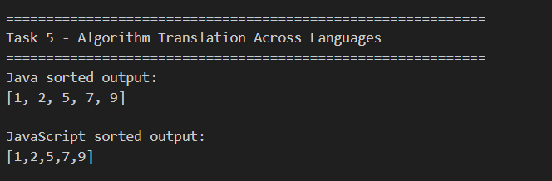

Justification
In the above task, we implemented manual array handling in C, where explicit sizes were defined due to the absence of dynamic typing. We managed memory using static arrays to ensure proper allocation and control. Despite these low-level implementations, we preserved the same logic as in the original approach.

